Feature Design “One-Pager” Document
Revision 0.1
ProxyClient Advanced URL to MC
Document Metadata
Current Author: Andrew Kiggins | Last Modified: 8/13/2008
Original Author: Andrew Kiggins | Creation Date: 8/13/2008
Document Phase: First Draft | Change Rate: Low
Document Currency: Current
If Deprecated, explain why and point to current document:
Intended Audience: Engineering, PM, QA, Doc | Security: Corporate
Auto-Generated RCS Entries (do not edit; to use, must identify file type as ktext in Perforce):
$Author: gary.tomic $
$DateTime: 2004/06/16 10:25:31 $
$Id: //proteusweb/docs/HowTo/DocTools/Wordtemplates/OnePagerTemplate.rtf#1 $

CONFIDENTIAL INFORMATION
Copyright 2001-2004 Blue Coat Systems Inc. All rights reserved worldwide. No part of this document may be reproduced by any means nor translated to any electronic medium without the written consent of Blue Coat Systems Inc. Specifications are subject to change without notice. Information contained in this document is believed to be accurate and reliable, however, Blue Coat Systems Inc. assumes no responsibility for its use, Blue Coat is a registered trademark of Blue Coat Systems Inc. in the U.S. and worldwide. All other trademarks mentioned in this document are the property of their respective owners.

Revision History
Revision | Date | Author | Comments
0.1 | 8/13/2008 | Andrew Kiggins

(Note: To insert graphics into this document, copy the image file into the same directory as the document, then link to it; don’t insert the graphic.)

Description
The requirement for this feature is driven by the ProxyClient Scorpius RD Req 3.9.2.
The AdvancedURL used to display the ProxyClient information in the MC is very dense and difficult to use with significant numbers of ProxyClients. To make this more usable the information will be moved to the MC. The data will be logically grouped and the capabilities for sorting and filtering added to allow easier browsing.
There is no plan to enhance the data transferred from the ProxyClient, therefore the information will be the same is currently available in 5.3.
This implementation is a subset of the Scorpius Diags FS which is targeted at Scorpius, and has been plagiarized mercilessly.

Design
Two submenus will be added under the Statistics->ProxyClient menu. History will show the same information as is currently available under the Statistics->ProxyClient in 5.3. Details will show the information currently displayed in the AdvancedURL ProxyClient
The Client Details Panel will contain a set of 4 tabs each of which will display a set of tabulated information.
Each table will contain a set of associated information. Each table will be sortable, ascending or descending, by any column in the table.
Each table will be filterable by a column type. Each column will have a corresponding entry in a combo box, which has and value input field. A value can be specified for a select set of columns and the data will be filtered accordingly.

Design Assumptions
An AdvancedURL will be used to retrieve the ProxyClient data. This will provide XML formatted data to the MC.

System Fit
This feature will supplement the AdvancedURL Statistics->Advanced->ProxyClient(View details of all connected clients), which will be retained to support existing customer usage patterns.

Implementation Design
Implementation and unit testing will be completed in a sub branch of 5.4 and the re-integrated into the 5.4 branch when unit testing is complete.

UI Impact

MC
The current ProxyClient screens will be extended to include two new submenus.
The History submenu option will show the existing historical stats as per the ProxyClient option in 5.3.
The Details submenu will show the diagnostics information currently available in the ProxyClient Advanced URL.
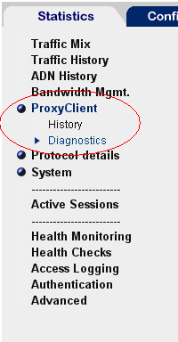

The Details submenu will show a tabbed panel with the diagnostics information from the ProxyClients. The Client Version Count tab shows the number of active and inactive clients currently running a given version.

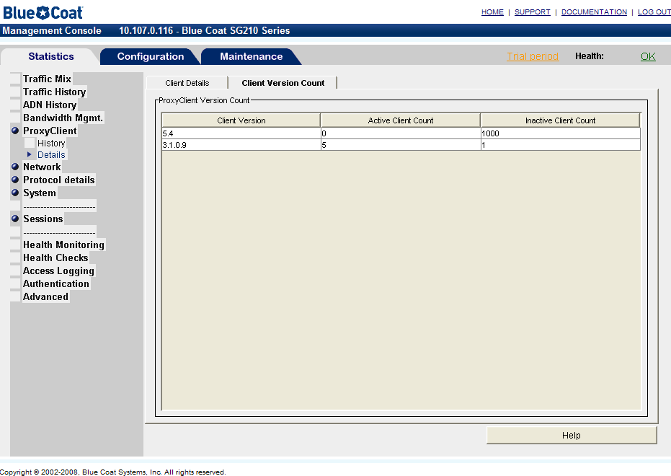

The Client Details tab shows individual client information grouped into separate tabs. The tabs are General, Aceleration, Filtering and All. Each tab shows a different set of data, grouped according to function.
In any table in the Client Details tab it is possible to filter the content by adding one or more filter fields from the dropdown in the top panel.
The data in the table can be sorted ascending or descending using the contents of any column being displayed.
This is done by clicking on the header of the column to be used for sorting.

“Active” column is now “Status”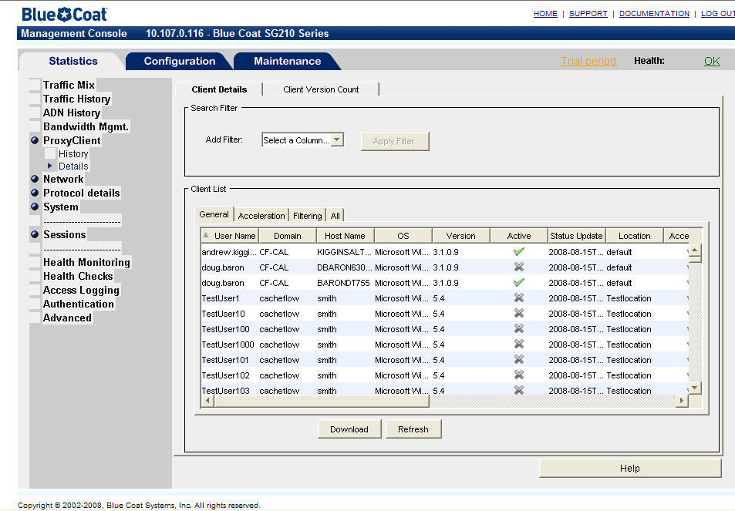
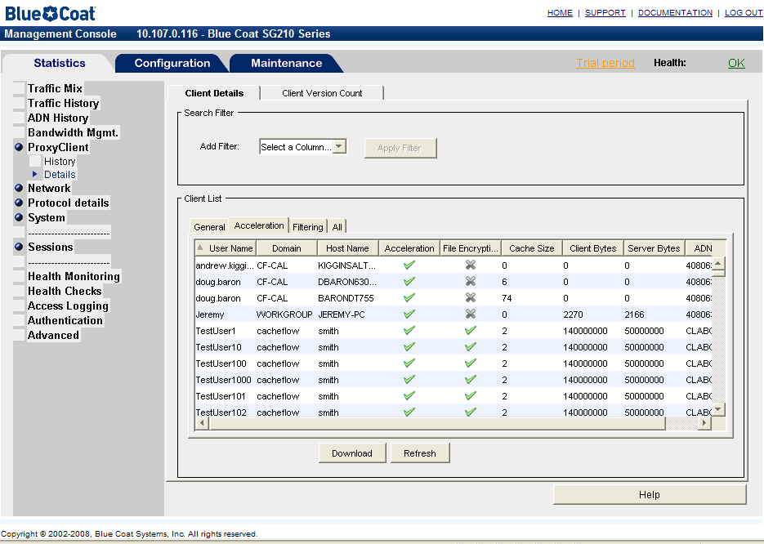
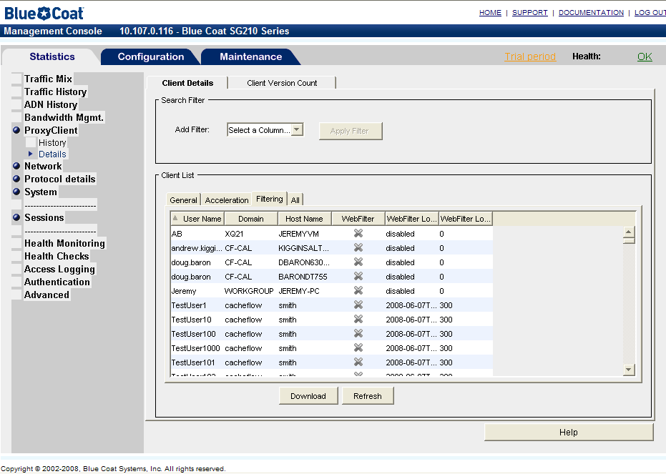

CLI
The command will be extended to allow filters to be applied to the data before it is displayed on the screen.

10.107.0.50 - Blue Coat SG210 Series>show proxy-client clients ?
<enter>
-ClientVersion <version>
-UserName <username>
-NetworkDomain <domain>
-Host Name <hostname>
-OS <os>
-Location <location>
-Active [yes|no]

This will filter the clients displayed at the CLI. Only those clients matching the filter criterion will be displayed.
The format of the display will not change.

Security Impact
None

Policy Impact
None.

Integration and Testability
None.

Risks and Open Issues
None.

